**CSY 4010 Computing Dissertation: Interim Report**

Parking Management System: real time update and automate tickets

by

SHREEJAH TULADHAR

UoN ID - 23834848

BSc Computing (Software Engineering)

2025

Table of Contents

List of figures 4

List of tables 5

1. Introduction 6

1.1 Project Background 6

1.2 Aim and Objectives 6

1.3 Literature Review 7

**1.3.1** **Comparable systems** 7

**1.3.2** **Academic Journals** 9

1.4 Project Methodology 11

**1.4.1** **Software requirements engineering and solution specification** 11

**1.4.2** **System Analysis and Design** 12

**1.4.3** **System Implementation** 12

2 REQUIREMENT Engineering 13

2.1 Elicitation Activities 13

**2.1.1** **Survey and Questionnaires** 13

**2.1.2** **Stakeholder workshop** 14

**2.1.3** **Use case analysis** 15

2.2 REQUIREMENTS SPECIFICATION 17

**2.2.1** **Problem Domain Description** 17

**2.2.2** **Functional Requirements** 18

**2.2.3** **Non-functional requirements:** 21

**2.2.4** **Design Constraint** 21

**2.2.5** **Commercial Constraint** 21

3 System analysis and design 22

3.1 Preliminary Design 22

**3.1.1** **Significant Event Analysis** 22

**3.1.2** **Commands, Queries and Constraints** 23

3.2 Detailed System Architecture 28

**3.2.1** **System Architecture Design** 28

**3.2.2** **BON System Architecture Diagram** 29

3.3 System Database Design 30

**3.3.1** **ERD** 30

**3.3.2** **Database Schema** 31

4 System Interface Designs 36

4.1 Draft Interface Designs 36

**4.1.1** Wireframes 36

**4.1.2** **Mock-up Screen** 46

**4.1.3** **Use Case diagram** 47

**4.1.4** **Sequence diagram** 48

5 SYSTEM BUILD NOTES 50

6 Testing strategy 51

6.1 Synopsis of Testing 51

6.2 Test results 51

7 SYsteM Evaluation 52

7.1 Usability Evaluation 52

7.2 Project Conclusions 52

References 53

Appendix 1: GANTT CHARTS 54

# List of figures

Figure 1 User BON class chart 23

Figure 2 Admin BON class chart 24

Figure 3 Parking owner BON class chart 25

Figure 4 Violation BON class chart 26

Figure 5 Vehicle BON class chart 27

Figure 6 System architecture diagram 28

Figure 7 BON system architecture diagram 29

Figure 8 ER diagram of parking management system 30

Figure 9 ParkingLocations object schema 31

Figure 10 Users object Schema 32

Figure 11 Bookings object Schema 33

Figure 12 ParkingOwners object schema 34

Figure 13 Violatoins object schema 35

Figure 14 wireframe of user searching for parking space 36

Figure 15 wireframe of admin dashboard 37

Figure 16 wireframe of parking owner dashboard 38

Figure 17 wireframe of user dashboard 39

Figure 18 wireframe of parking owner and admin displaying all the booking list 40

Figure 19 wireframe of user adding vehicle information 41

Figure 20 wireframe of parking owner and admin adding violation by a vehicle form 42

Figure 21 wireframe of parking owner and admin adding parking space details 43

Figure 22 wireframe of admin adding parking owner form 44

Figure 23 wireframe of user booking parking space 45

Figure 24 Mock-up screen of user searching for parking location 46

Figure 25 use case diagram of parking management system 47

Figure 26 Sequence diagram of user booking a parking space 48

Figure 27 Sequence diagram of user digital payment for booking 49

Figure 28 code connecting to database 50

Figure 29 previous estimated timeline 54

Figure 30 current timeline indicated by red line 55

Figure 31 supervisor log 1 56

Figure 32 supervisor log 2 57

# List of tables

Table 1 comparable systems for parking management system 7

Table 2 Elicitation activities and its advantages and disadvantages 11

Table 3 system implementation choice 12

Table 4 List of use case for parking management system 16

Table 5 Significant event analysis for parking management system 22

# Introduction

Parking Management System is a parking strategy that combines technology and human innovation to use as few resources as possible to achieve faster and easier parking of vehicles. Drivers in urban areas find it hard to locate secure parking space. The system should allow real-time data to be obtained about parking availability to assist drivers in improving several issues related to parking.

## Project Background

Searching for parking space create congestion, accidents, and pollution. Parking along the road brings out insecurity of vehicles and some avoid paying parking fees which is a challenge to the Parking owners/Administrators. Parking Management System services can significantly ease these problems by guiding a driver directly to a parking space. Cities worldwide have implemented smart parking system and planned automation to improve efficiency, reduce revenue loss, and manage space better.

## Aim and Objectives

The aim of this project is to develop a digital parking management system that includes:

* Finding parking locations
* booking parking locations
* Real time updates of locations
* Online payment system
* Recommend locations

And to achieve this target the list of objectives to complete are:

* Understand the current system and analyze the requirements to create a digital platform.
* Explore other systems and compare to see what improvements can be done.
* Find problem domain for the system.
* Complete elicitation activities such as surveys, use-case analysis, and workshops to gather the requirements.
* Create designs for the system which will make development reliable and fast.
* Use scrum framework an agile approach to develop the system.
* Begin the implementation, create a backend that handles all logic and frontend for easy-to-use user interface.
* Testing the system while developing it and fix the issues as the problems arise.
* A report of all problems tested will be added in a table.
* List out the evaluation of performance of the system.

## Literature Review

Here is the Literature review for this project which has two sections. Initially, the comparable systems where existing systems are taken as reference and list out the system features, advantage, and disadvantage. Then Academic journal review a summary of the papers related to our systems to understand the current technologies and findings of experts in the field.

### **Comparable systems**

*Table 1 comparable systems for parking management system*

|  |  |
| --- | --- |
| Parkopedia | (Parkopedia, 2025) |
| Features | * Search for parking by location * Real-time availability * Price comparisons * User-contributed data * Filters parking search (e.g., EV charging, free parking) |
| Advantages**:** | * Users can access detailed information such as pricing, hours, restrictions, and space types * Allows filtering for features like free parking, electric charging, and indoor vs. outdoor lots, making it easy to find specific parking needs. * Users can add and update parking data, keeping the database relatively current and diverse. |
| Disadvantages**:** | * user reports can make the availability data unreliable. * Doesn't allow users to book or pay for parking directly in the app. * Although it depends on user input, there is little incentive or reward for those who update parking data. |
| Eparking | (Store, 2025) |
| Features | * Real-time parking occupancy data * Color-coded availability indicators * Integration with municipal parking systems * Directions to available spots |
| Advantages | * Uses live data feeds to show current parking availability in supported cities, reducing time spent searching. * Parking areas are color-coded (e.g., green, yellow, red) based on availability of location for quick visual guidance. * Many systems are connected to parking sensors, enhancing accuracy and reliability. |
| Disadvantages | * Works in major cities with smart parking infrastructure, leaving out suburban and rural areas. * The experience can vary greatly depending on the city or country, as there is no unified global version. * Doesn’t allow pre-booking or payment within the app. |
| SpotHero | (SportHero, 2025) |
| Features | * Pre-booking of parking spots * Search by time, location, and price * Digital parking passes * Integration with garages and lots |
| Advantages | * Allows users to reserve a parking spot in advance. * Users often receive better prices through the app compared to drive-up rates. * The app generates a digital pass that users can scan or show, making the entry and exit process smooth. |
| Disadvantages | * It doesn't provide real-time information about street parking availability. * Some bookings cannot be easily canceled, or may incur fees, reducing flexibility. * mainly works in United states and lacks international coverage. |
| ParkWhiz | (parkWhiz, 2025) |
| Features | * Search and reserve parking in advance * Mobile passes for entry * Price comparison * Event parking (e.g., concerts, sports) |
| Advantages | * Users can reserve spots in advance, particularly helpful for concerts, sporting events, and city commutes. * Many garages use QR or license plate recognition, allowing seamless entry with your phone. * The app is easy to navigate, with a clear layout for finding, reserving, and managing parking. |
| Disadvantages | * Does not include public parking options, which may be cheaper or closer in some areas. * Some cities have better integration and more options than others. * Doesn’t show live updates on whether a lot is near capacity. |

### **Academic Journals**

List of IEEE (Institute of Electrical and Electronics Engineers) papers referred for this project:

* ‘Research and design of intelligent parking management system based on UML technology’ (Li Lyu, 2023)  
    
  This article introduces the design and development of an Internet of Things and Unified Modeling Language-based intelligent parking system that improves system modeling and architectural transparency. The proliferation of IoT devices within parking garages, making information administration and centralized control challenging.   
    
  The project is investigating the way UML improves visual understanding and coordination within complex system design, particularly within environments that feature many real-time data inputs through sensors, users, and administrators. The implementation of UML is a judicious direction towards building an IoT-based parking system. In combination with smart hardware, this modeling approach can significantly improve parking operations, eliminate error operations, and improve administrator and user experiences.
* ‘Exploring the Complexities of GPS Navigation: Addressing Challenges and Solutions in the Functionality of Google Maps’ (Ashish Dhoke, 2024)  
    
  This article provides a detailed overview of the challenges confronting Google Maps, one of the world's most popular GPS navigation systems. The authors address a variety of technical and user-related challenges, including data accuracy, real-time responsiveness, geographic processing, and user interface complexity. The authors discuss Google Maps' business model, from its spatial information processing, aggregation of traffic feeds, and application of routing computation algorithms. The study ends by suggesting an architectural framework to improve map rendering, routing performance, system scalability, and merging real-time user feedback.  
    
  The study emphasizes the need for continuous evolution of navigation systems like Google Maps in response to growing technological complexity and user expectations.
* ‘Preventing Fraud in E-tickets Validation Using The 2FA Approach’  
   (Lolwa Hassan Alnuaimi, 2024)  
    
  Using This paper outlines the growing vulnerability of electronic ticketing (e-tickets) fraud, particularly for mass events. The authors introduce Ticket_Events, a new mobile application that verifies e-tickets using a Two-Factor Authentication process. The system combines secure QR code creation with an added verification process based on user identity to prevent ticketing forgery, misuse, and counterfeiting.

The main topics of the paper are:

1. Weaknesses in contemporary QR/barcode tickets
2. Need for real-time validation and individual access control
3. Leverage 2FA to make the system more secure through something the user has (e.g., ticket/QR) and something the user knows (e.g., OTP, app authentication).
4. Event ticketing requires scanning and secondary verification upon entry to venues.

* ‘A Hybrid Travel and Parking Ticket Pass for the United Arab Emirates Transport Services’ (Y. Tanvi, 2024)  
    
  A project to revamp the transportation and parking infrastructures of the United Arab Emirates (UAE) by establishing a hybrid digital system. The authors present an online-based system with integrated RFID (Radio-Frequency Identification) and blockchain security that marries traveling and parking ticketing systems in one setup. This is to overcome fragmented and obsolete systems still being used in various parts of the UAE, such as cash-based ticketing and SMS payment with low card acceptance and no sharing of family wallets.

The argument in the paper is that the proposed hybrid system can overcome most of the shortcomings in the UAE's current transport and parking ticketing landscape. The authors suggest that with wider deployment and continued enhancements, such hybrid systems could significantly raise the standard of public service delivery in smart cities.

* ‘Enhancing Navigation Systems: A Comprehensive Survey with Proposed Innovations for Improved User Experience’ (Ashwini Sunil Chaure, 2024)  
    
  The main idea is to update navigation systems with recent technology and human-centered design. The paper explains how hybrid navigation techniques, i.e., GNSS + INS, improve accuracy and robustness.

How vehicle and infrastructure networks of cooperative vehicles assist in providing dynamic updates. Use of smart recommendation systems to provide context-aware, adaptive route recommendations. Pay attention to user experience design, with a focus on navigation interface trust, ease of use, and personalization.

The authors conclude that while navigation technologies of today have come a long way, issues like signal degradation, urban canyon effects, latency in real-time information, and lack of personalization still afflict them.

## Project Methodology

### **Software requirements engineering and solution specification**

The requirement engineering process was conducted using structured surveys, targeted questionnaires, stakeholder workshops, and use case analysis. This approach enabled the identification of user needs and expectations across three main stakeholder groups: general users, parking owners, and system administrators.

**Elicitation techniques:**

*Table 2 Elicitation activities and its advantages and disadvantages*

|  |  |
| --- | --- |
| Surveys and questionnaires | Surveys were selected to gather insights from many potential users efficiently. Since the system targets public users and drivers, surveys allowed the collection of a broad range of opinions regarding preferences, expectations, and parking behavior. |
| Advantages | * Gathers quantifiable data for statistical analysis. * Anonymous responses encourage honest feedback * Useful for identifying common user pain points |
| Disadvantages | * Lacks detailed explanations * Poorly designed questions may lead to misinterpretation * Response rates can vary significantly |
| Stakeholder workshops | Workshops were conducted with parking owners and administrators to facilitate collaborative discussions and to uncover nuanced operational challenges. These sessions enabled real-time brainstorming of solutions, identification of conflicts, and prioritization of needs. |
| Advantages | * Encourages dialogue and negotiation between stakeholders * Promotes shared understanding of the system’s goals * Allows quick clarification of complex issues |
| Disadvantages | * Requires scheduling and active participation * May be influenced by dominant personalities in the group * Logistically harder to conduct with large groups |
| Use-case analysis | Use case analysis is conducted to understand use requirement and system behavior. This can target the user’s needs and make sure what to do to solve the problem. |
| Advantages | * Easier to understand user needs and interaction with system * Functional requirements are defined clearly * Can validate the system design to the user needs |
| Disadvantages | * Not suitable for non-functional requirements * Chances of redundancy due to overlapping of use cases. * Suitable level of detail is hard to determine and can lead it to become too complex or unclear to understand |

### **System Analysis and Design**

The different system analysis and design approaches are listed below:

1. UML Diagrams to visualize structure and behavior such as Use Case Diagram and Sequence Diagram

2. Entity-Relationship Diagram to design the database structure.

3. System architecture design

4. UI/UX Design with Figma to design front-end user experiences wireframes.

### **System Implementation**

The Parking Management System will be built as a hybrid platform that combines web and mobile applications to improve accessibility for public users, parking owners, and administrators.

Justification of Technology Choices:

*Table 3 system implementation choice*

|  |  |  |  |  |  |  |  |  |  |  |  |  |  |  |  |  |  |  |  |  |
| --- | --- | --- | --- | --- | --- | --- | --- | --- | --- | --- | --- | --- | --- | --- | --- | --- | --- | --- | --- | --- |
| | Component |  |  | | --- | --- | --- | |  |  |  | |  |  |  | |  |  |  | |  |  |  | |  |  |  | | Technology | Justification |
| Web Frontend | React.js + Maps API | Modern UI, responsive, geolocation integration |
| Mobile App | React Native | Shared codebase for iOS/Android, device integration |
| Backend | Node.js + Express | Non-blocking, scalable, ideal for real-time systems |
| Databases | MongoDB | Unstructured object based storage solution. |
| Real-time Updates | WebSockets/Socket.io | Efficient live communication for availability tracking and alerts |

# REQUIREMENT Engineering

## Elicitation Activities

For this project the techniques chosen to gather requirements are survey and questionnaires, stakeholder workshop and use-case analysis.

### **Survey and Questionnaires**

Here is a general plan for conducting online survey for parking management. The target audience for this system are public users. The expected sample size more than 1000.

Objectives:

* Assess user satisfaction with existing system
* identify areas of improvement
* gather feedback on features
* understand the preferences of technologies

For the development of the survey, 50 questions will be in the form. Questions will be short and clear and without any biases. The answer will be in a response of Strongly Agree, Agree, Neutral, Disagree, and Strongly Disagree. At the end there will be an optional feedback section where users can add any missing details. Similar type of questions will be organized in a set. Google forms is the selected platform to conduct the online survey. The survey will be distributed via email, social media, websites, etc.

Data Collection and Analysis:

Once the data collection period is complete, export the data from the online survey platform. After the survey data has been collected, this data must be analyzed to ensure it aids towards the end research objective.

The collected data can be scaled numerically 1-5 and average can be calculated for each response.  
Also identify the trend of which answers score more and which scored less. Based on different user classification such as age, gender, job compare answers. Understanding anomalous data and filter out.

### **Stakeholder workshop**

Here is the plan for conduction stakeholder workshop. The aim of this workshop is to gather diverse perspectives and foster collaboration among stakeholders to improve the parking management system.

**Target audience:**

* Parking lot owners
* Parking lot managers/staff
* Regular parking users
* Public parking staff
* Public parking officers

Date: 30th May 2025, location: Nami College, Duration: 2 hours

Facilitator: Shreejah Tuladhar

**Workshop Agenda:**

1. Introduction (10 minutes)

Welcome and Overview of the workshop objectives and agenda with presentation on the current parking management system

2. Stakeholder Perspectives (30 minutes)

Discussion with representatives from each stakeholder:

* Parking lot owner: Focus on business aspects, revenue, and operational efficiency.
* Parking lot manager/staff: Focus on daily operations, challenges, and customer interactions.
* Regular parking user: Focus on user experience, convenience, and pain points.
* Public parking staff/officer: Focus on regulations, enforcement, and public needs.

Each person will have 4 minutes to share their perspective, followed by a Q&A session.

3. Problem Identification and Prioritization (25 minutes)

Participants will be divided into smaller groups. Each group will discuss and identify the key problems and challenges related to the current parking management system. Groups will then prioritize the top 3-5 problems based on their impact and urgency. Facilitator will guide the discussion and ensure all voices are heard. Note down ideas generated and rearrange list on basis of importance.

4. Solution Brainstorming (25 minutes)

Groups will continue to work on the prioritized problems from the previous session. The focus will shift to brainstorming potential solutions and improvements. Creative and innovative ideas, considering technology, policy changes, and operational adjustments will be encouraged. Each group will list out 2-3 solution proposals for each prioritized problem. Facilitator will ensure that the solutions are feasible and addresses the needs of different stakeholders.

5. Solution Evaluation and Action Planning (15 minutes)

Each group will present their proposed solutions. Open discussion and feedback from all participants will be done. Then selecting the most promising solutions. Develop an action plan for implementing the selected solutions. Identify key performance indicators to measure the success of the implemented solutions.

6. Wrap-up and Next Steps (15 minutes)

Thank participants for their contributions and summarize the workshop outcomes to outline the next steps in the process for development of system. Gather feedback on the workshop.

### **Use case analysis**

A use case is a description of the interactions between a user and a system to achieve a specific goal. It outlines the sequence of actions a system performs to provide a valuable result to the user. Use cases describe "what" the system should do, not "how" it should do it.

**Identifying Actors and Goals:**

The process begins by identifying the actors/ users that will interact with the system. For each actor, we determine their goals or objectives when using the system.

* Parking Customer: Parks their vehicle.
* Parking Attendant: Manages the parking facility.
* System Administrator: Maintains the PMS.
* Payment Gateway: Processes payments.

**Defining Use Cases:**

Each goal is then defined as a use case. The use case describes the series of steps the actor and the system take to achieve that goal. Elicitation workshops, user stories, and scenario building can be employed to detail these interactions.

*Table 4 List of use case for parking management system*

|  |  |  |
| --- | --- | --- |
| Actor | Use Case | Description |
| Parking Customer | Enter Parking Facility | Customer drives into the facility and the system records their entry time. |
| Parking Customer | Find Available Parking Space | Customer locates an empty parking spot using the system. |
| Parking Customer | Pay for Parking | Customer pays for their parking session using various methods. |
| Parking Customer | Exit Parking Facility | Customer leaves the facility, and the system calculates and processes their payment. |
| Parking Attendant | Manage Parking Spaces | Attendant monitors space availability, assigns spaces, and handles exceptions |
| Parking Attendant | Process Payments | Attendant handles cash payments or assists customers with payment issues. |
| Parking Attendant | Record violations | Attendant creates reports on vehicle violations |
| System Administrator | Configure System Settings | Administrator sets up and configures the PMS, including rates, user accounts, and system parameters. |
| System Administrator | Maintain System Database | Administrator manages the database, including backups, updates, and data integrity. |
| Payment Gateway | Process Payment Transaction | Gateway securely processes customer payments. |

## REQUIREMENTS SPECIFICATION

Software Requirements Specification is a comprehensive description of what a software system should do and how it should behave. It outlines both functional and non-functional requirements, providing a clear understanding of the system's purpose, expected performance, and constraints. The SRS acts as a contract ensuring everyone is on the same page regarding the software's functionality and quality.

### **Problem Domain Description**

The primary problem domains for a Parking Management System (PMS):

* **Parking Space Management:**

This domain deals with the allocation, tracking, and optimization of parking spaces within a facility. It includes:

1. Updating the status of parking spaces in real-time.
2. Efficiently assigning and managing parking spaces, including reservations, and handling different types of spaces.
3. Guiding customers to available spaces using signs, mobile apps, or other navigation tools, and recommending optimal parking locations based on factors like proximity to destination or type of vehicle.

* **Customer Management:**

This domain focuses on the interaction with parking customers, including entry and exit processes, payment processing, and handling customer inquiries or issues.

* **Transaction Management:**

This domain involves the handling of financial transactions related to parking, including:

1. Processing parking fees automatically through various methods (e.g., mobile apps, online platforms, contactless payment).
2. Calculating fees, processing payments, generating receipts, and managing payment methods.

* **System Administration:**

This domain encompasses the configuration, maintenance, and monitoring of the PMS itself, including setting system parameters, managing user accounts, and ensuring system security and reliability.

### **Functional Requirements**

Based on the identified problem domains, here are the functional requirements for a Parking Management System:

**1. Parking Space Management**

* **Real-time Parking Availability:**

1. Monitor the occupancy status of each parking space in real-time.
2. Update the parking space status automatically upon vehicle entry and exit.
3. Provide a real-time display of available parking spaces to customers.
4. Allow parking attendants to manually update the status of a parking space.

* **Space Management:**

1. Manage the allocation of parking spaces to vehicles.
2. Support parking reservations, allowing customers to reserve a parking space in advance.
3. Manage different types of parking spaces, including:

* Regular parking spaces.
* Handicapped parking spaces.
* Electric vehicle charging spaces.
* Reserved spaces.

1. Optimize parking space allocation to maximize utilization.

* **Navigation and Recommendation of Parking Locations:**

1. Provide navigation guidance to customers to direct them to available parking spaces.
2. Use signs to indicate available parking spaces and directions.
3. Provide a mobile app for customers to:

* View a map of the parking facility.
* See real-time parking availability.
* Receive directions to available parking spaces.

1. Recommend optimal parking locations to customers based on:

* Proximity to their destination.
* Vehicle type.
* Parking space type preference.

**2. Customer Management**

* The system shall manage customer entry to the parking facility, including:

1. Recording vehicle information upon entry.
2. Issuing parking tickets to verify reaching of parking
3. Allow entrance

* The system shall manage customer exit from the parking facility, including:

1. Verifying payment before exit.
2. Allow exit.
3. Recording exit time.

* Provide a user-friendly interface for customers to interact with the system.
* Handle customer inquiries and issues, including providing support and resolving problems.

**3. Transaction Management**

* **Automating Payment:**
  + Calculate parking fees based on:
    1. Entry and exit times.
    2. Parking duration.
    3. Applicable rates and discounts.
  + Support various payment methods, including:

1. Cash payments.
2. Credit/debit card payments.
3. Mobile payments
   * Process payments securely.
   * Generate and provide payment receipts to customers.
   * Record all payment transactions.
   * Generate reports on parking revenue.

**4. System Administration**

* Provide an administrative interface for system configuration and management.
* Allow administrators to configure system parameters, including:

1. Parking rates.
2. Operating hours.
3. User roles and permissions.
4. System security settings.

* Manage user accounts, including:

1. Creating and deleting user accounts.
2. Assigning user roles and permissions.
3. Managing user authentication and authorization.

* Monitor system performance and provide alerts for any issues.
* Maintain a database of all relevant data, including parking space status, customer information, and transaction records.
* Have security measures in place to protect against unauthorized access and data breaches.

**5. Enforcement**

* The system shall allow parking admin to:
  + Check the validity of parking permits.
  + Issue parking violations (e.g., for expired permits, unauthorized parking).
  + Record and track parking violations.
  + Generate violation notices.

### **Non-functional requirements:**

1. Performance:

System supports basic real-time operations with quick data refresh interval.

Transaction Processing Time Should process within few seconds.

System Response Time fetching data should process within few seconds.

Failure Rate: Crash and failures should be limited.

1. Security:

Two-Factor Authentication (2FA) will be implemented.

All user data and payment information must be securely encrypted.

limit suspicious access to unauthorized logins.

1. Scalability:

System is designed for limited scale deployment with no need for high concurrency handling.

1. Availability: Basic availability with routine downtime for maintenance is acceptable.

### **Design Constraint**

There is no restriction to the design of the system. Considering this a suitable design which will suit the theme of parking management system will be used. The design will be created by following the basic principles of UI/UX to have an easy-to-use interface.

### **Commercial Constraint**

This is a general use project so the budget for this system in zero, the deadline for this project is set at the 25 August 2025.

# System analysis and design

## Preliminary Design

### **Significant Event Analysis**

*Table 5 Significant event analysis for parking management system*

|  |  |  |
| --- | --- | --- |
| Significant event | Performers | Attributes |
| search location | user  parking owner  admin | input search  map  valid user |
| book parking | user  parking owner admin  admin | online form  valid user  available parking space |
| Add parking owner | admin | online form  owner information  parking space information |
| Add parking space | parking owner  admin | online form  parking space information |
| Add vehicle | user | online form  vehicle information |
| process payment | user  parking owner  admin | payment method  verify payment |
| Add violation | parking owner  admin | vehicle information  type of violation |

### **Commands, Queries and Constraints**

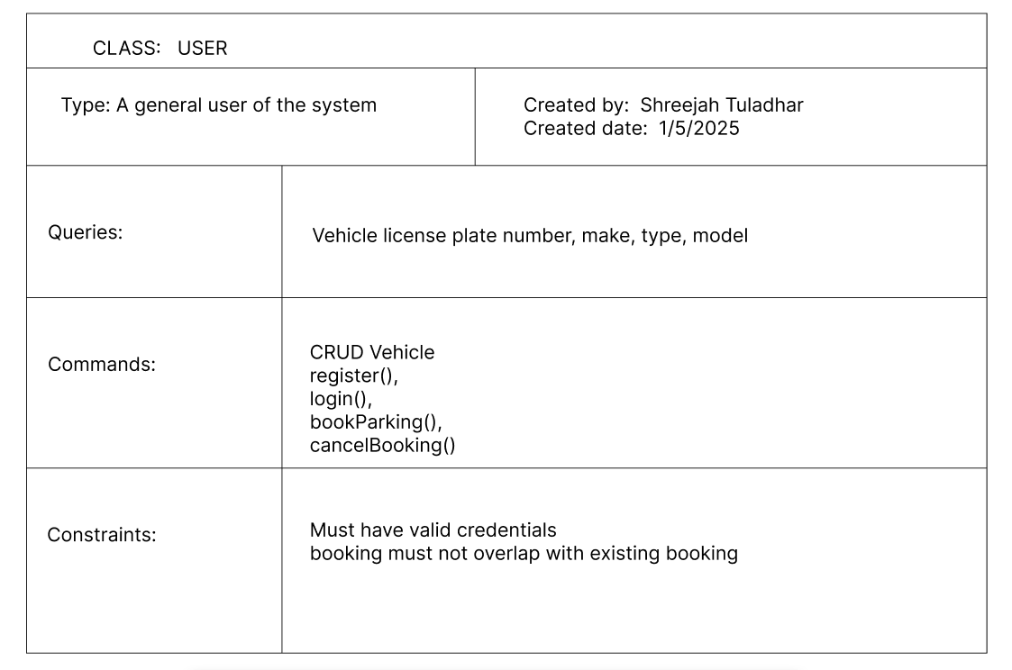

*Figure 1 User BON class chart*

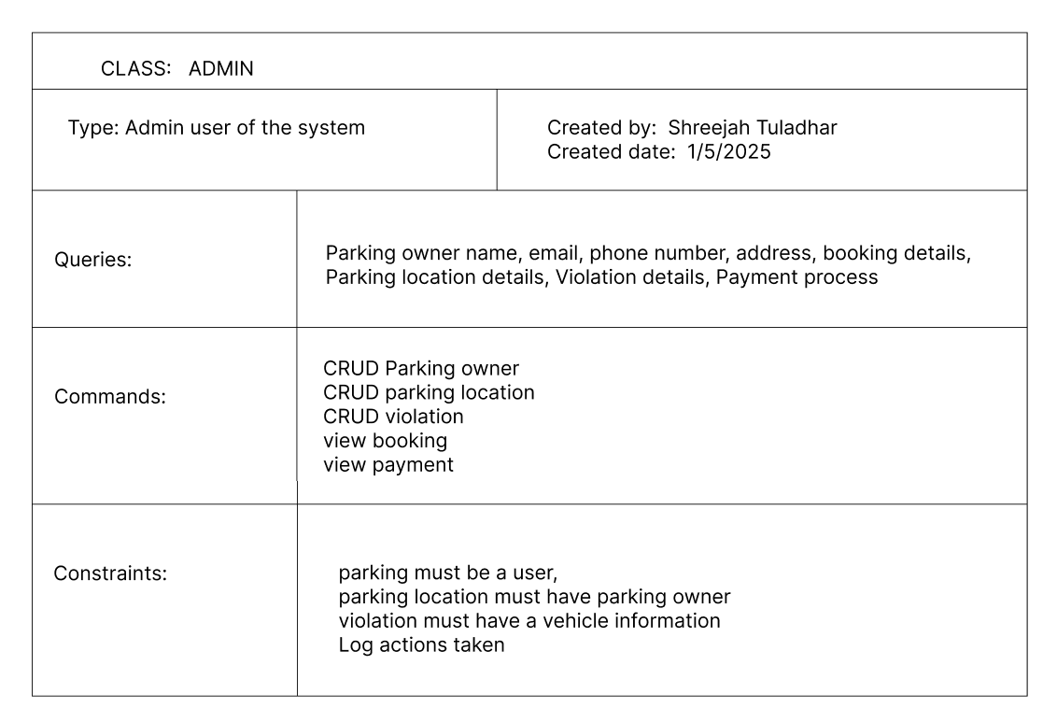

*Figure 2 Admin BON class chart*

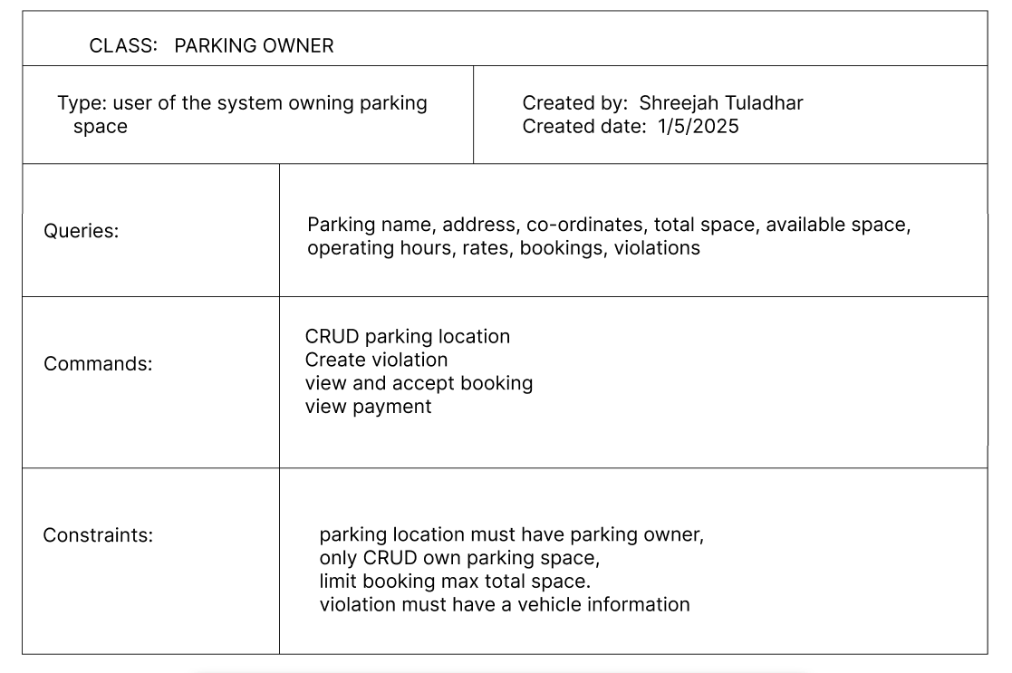

*Figure 3 Parking owner BON class chart*

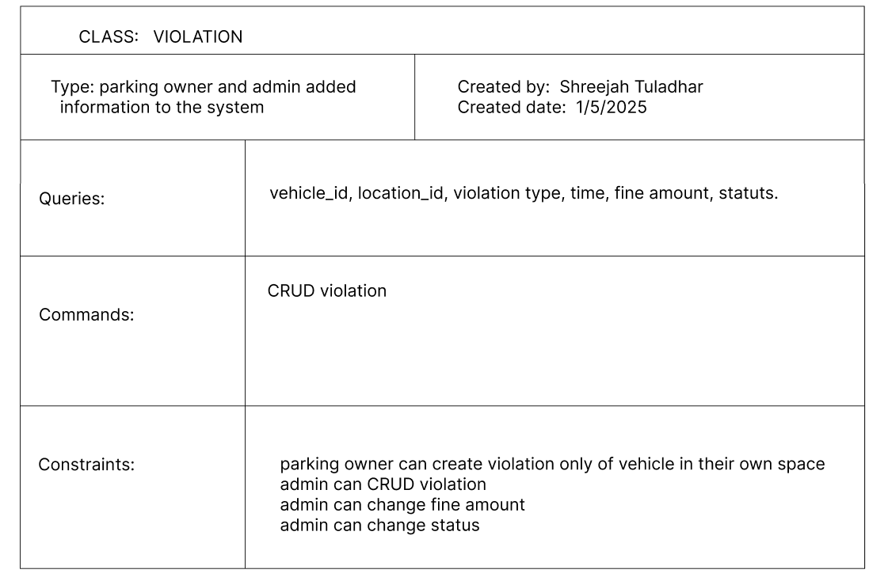

*Figure 4 Violation BON class chart*

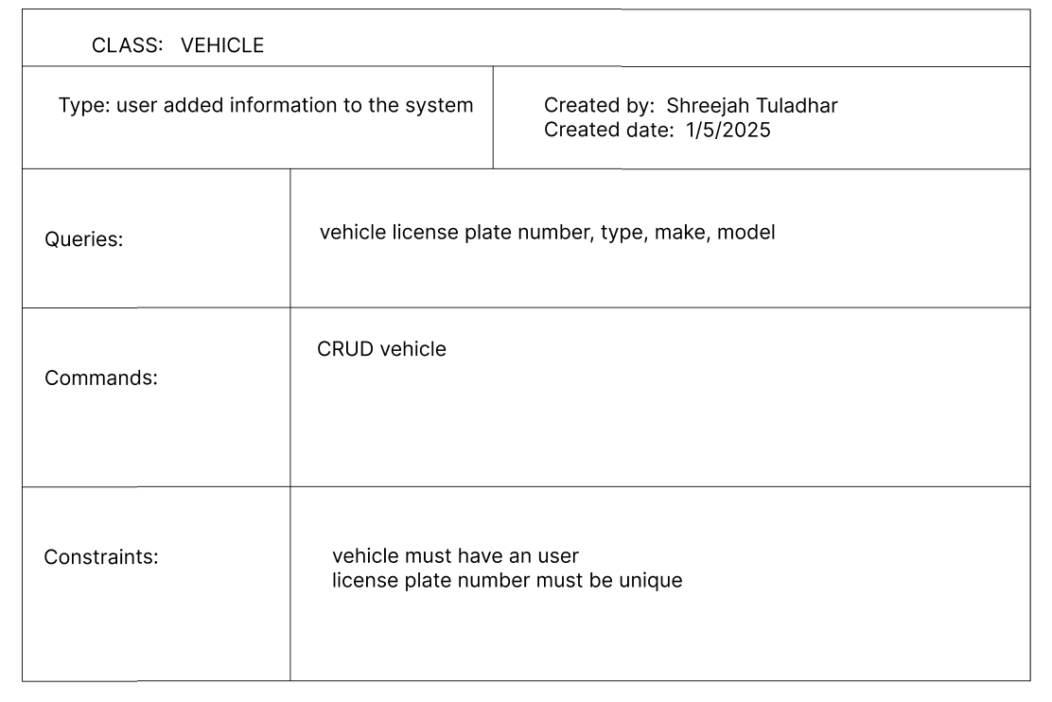

*Figure 5 Vehicle BON class chart*

## **Detailed System Architecture**

### **System Architecture Design**

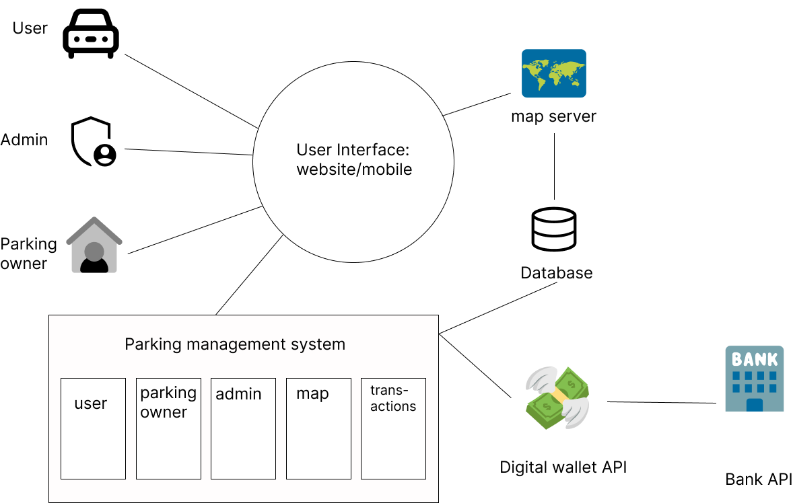

*Figure 6 System architecture diagram*

### **BON System Architecture Diagram**

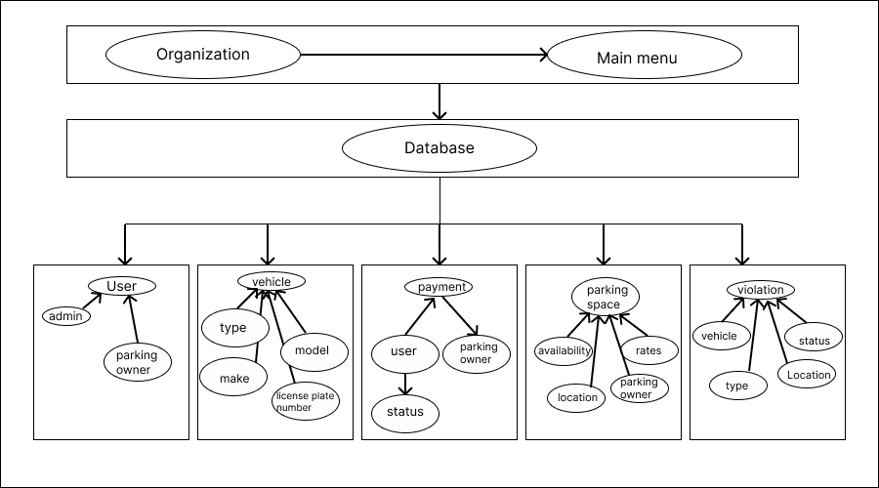

*Figure 7 BON system architecture diagram*

## System Database Design

### **ERD**

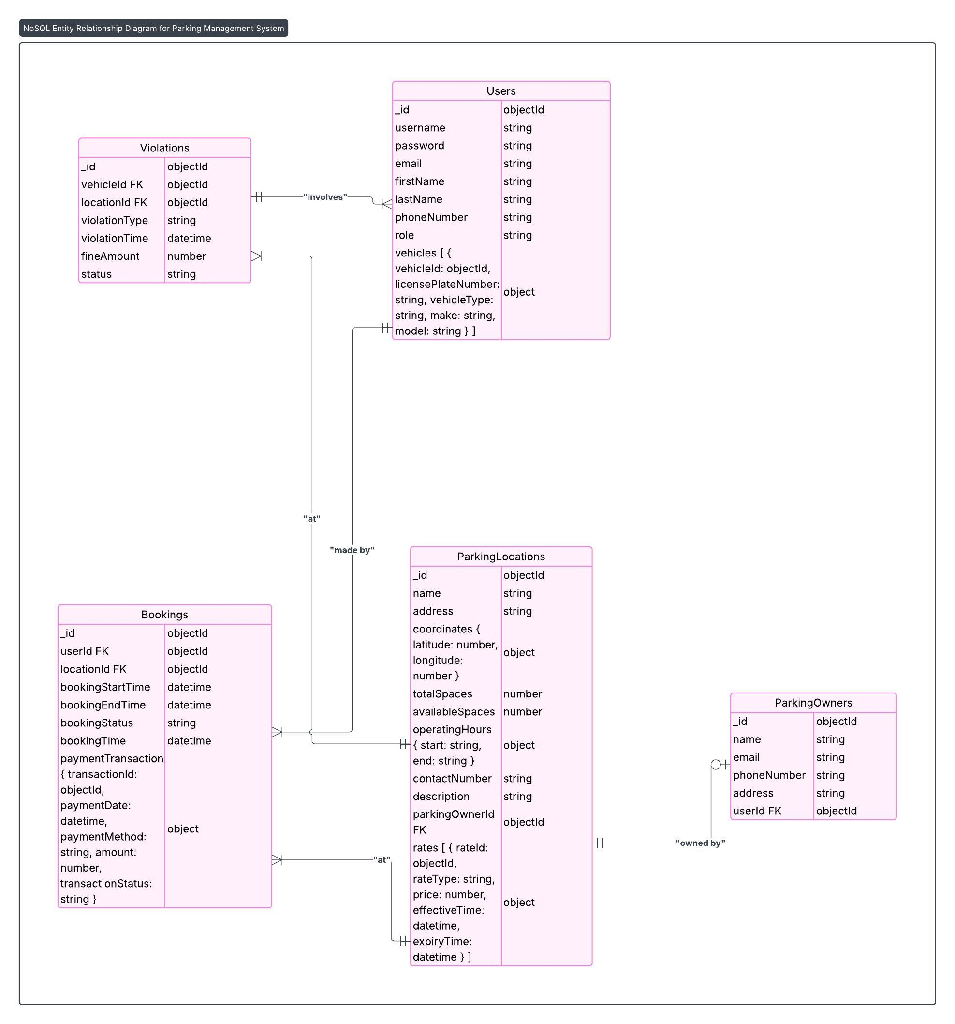

*Figure 8 ER diagram of parking management system*

### **Database Schema**

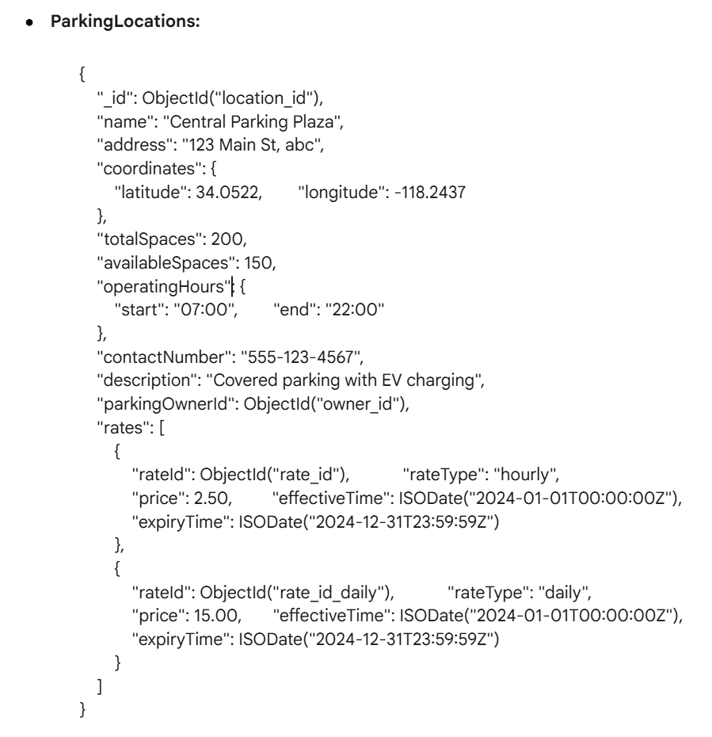

*Figure 9 ParkingLocations object schema*

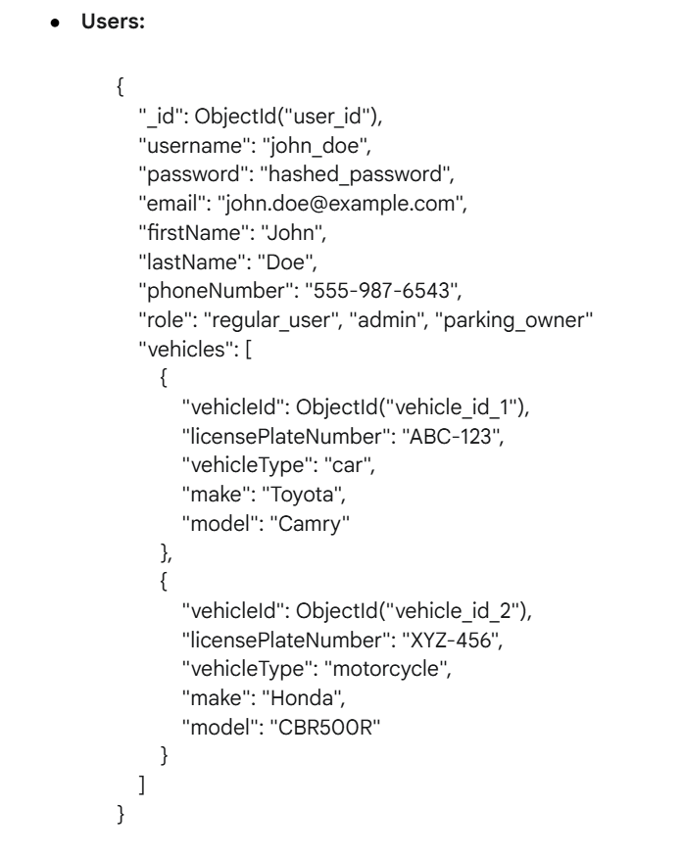

*Figure 10 Users object Schema*

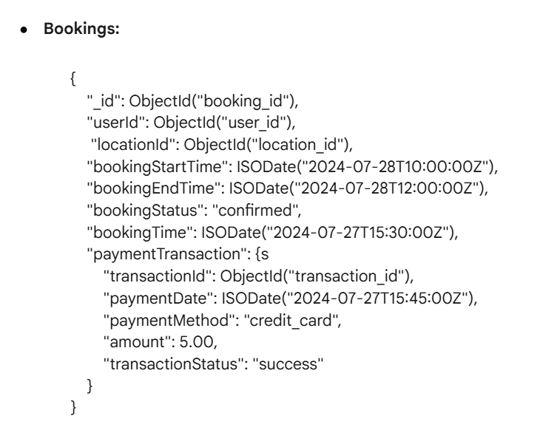

*Figure 11 Bookings object Schema*

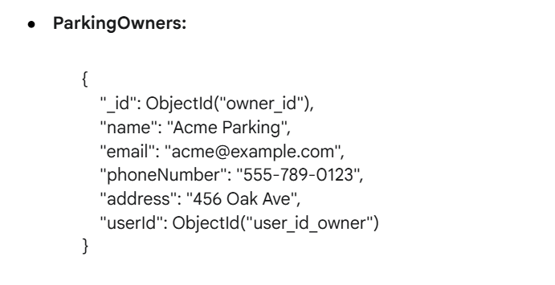

*Figure 12 ParkingOwners object schema*

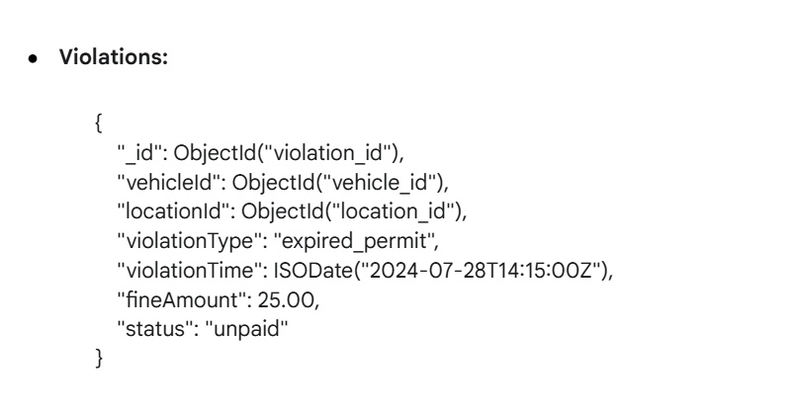

*Figure 13 Violatoins object schema*

# **System Interface Designs**

## Draft Interface Designs

### Wireframes

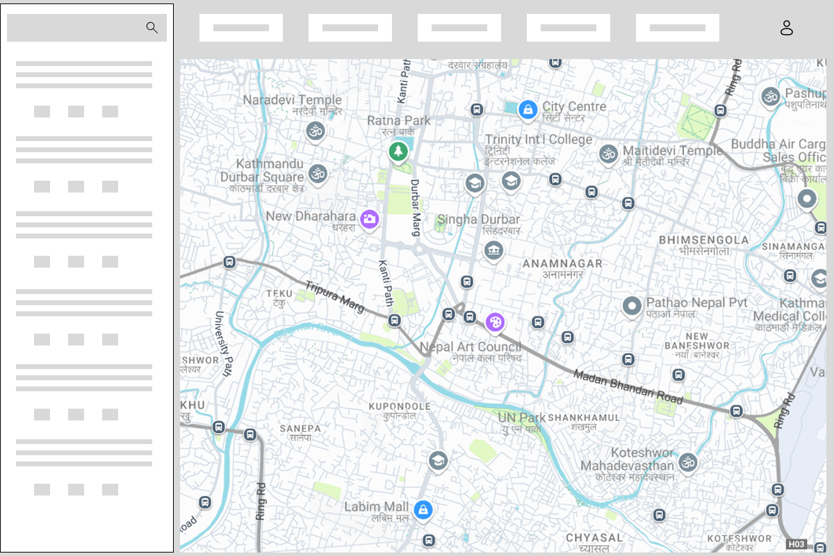

*Figure 14 wireframe of user searching for parking space*

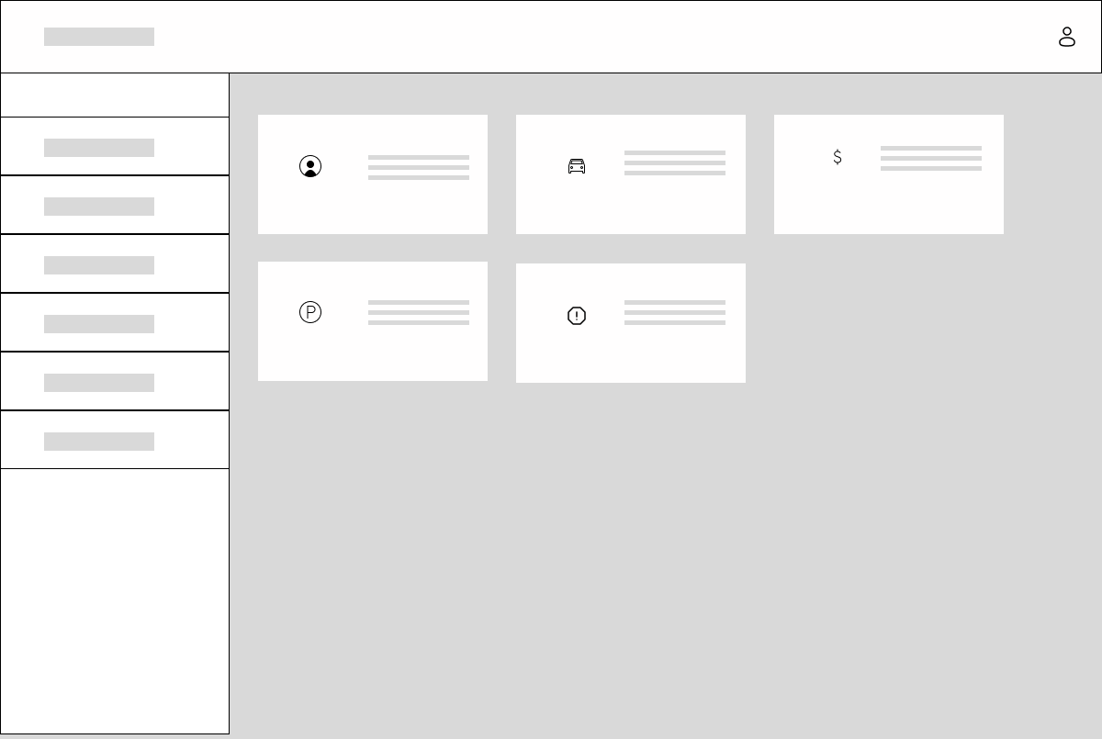

*Figure 15 wireframe of admin dashboard*

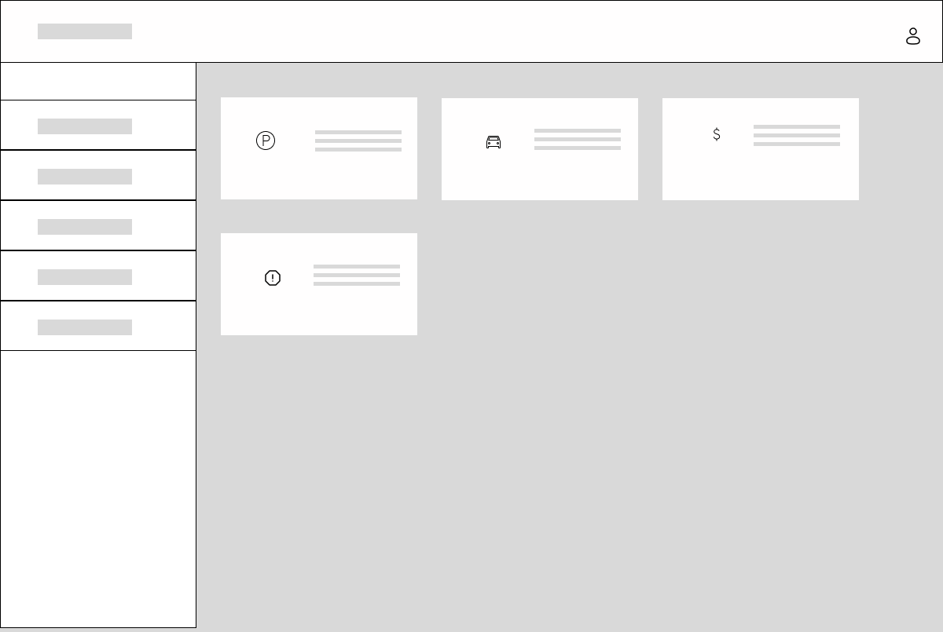

*Figure 16 wireframe of parking owner dashboard*

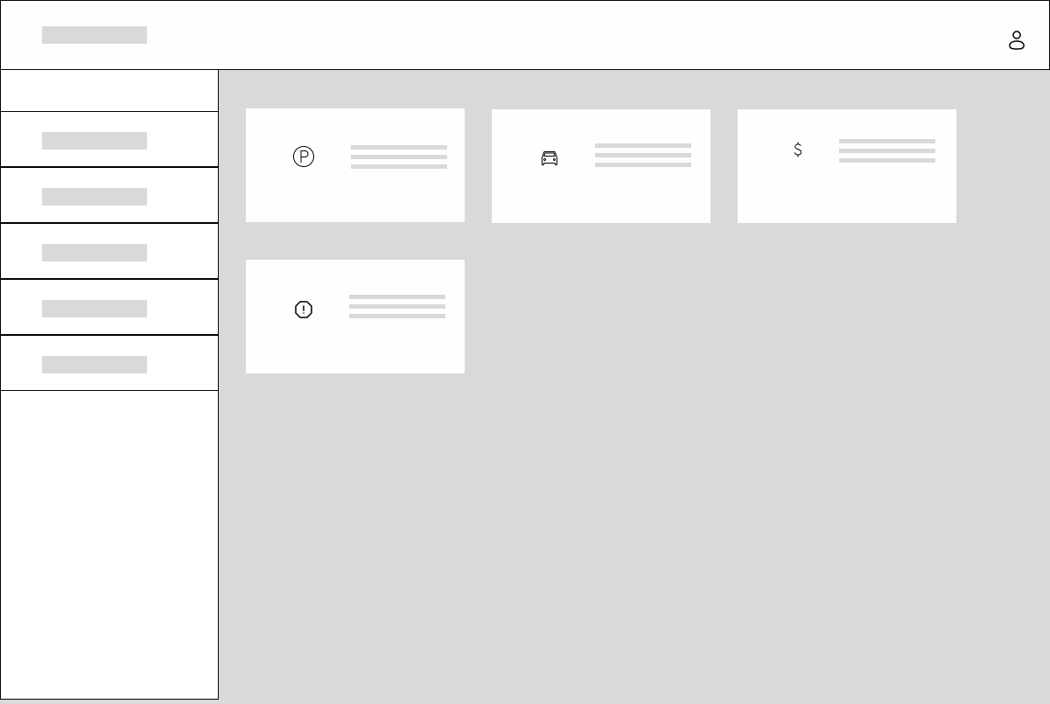

*Figure 17 wireframe of user dashboard*

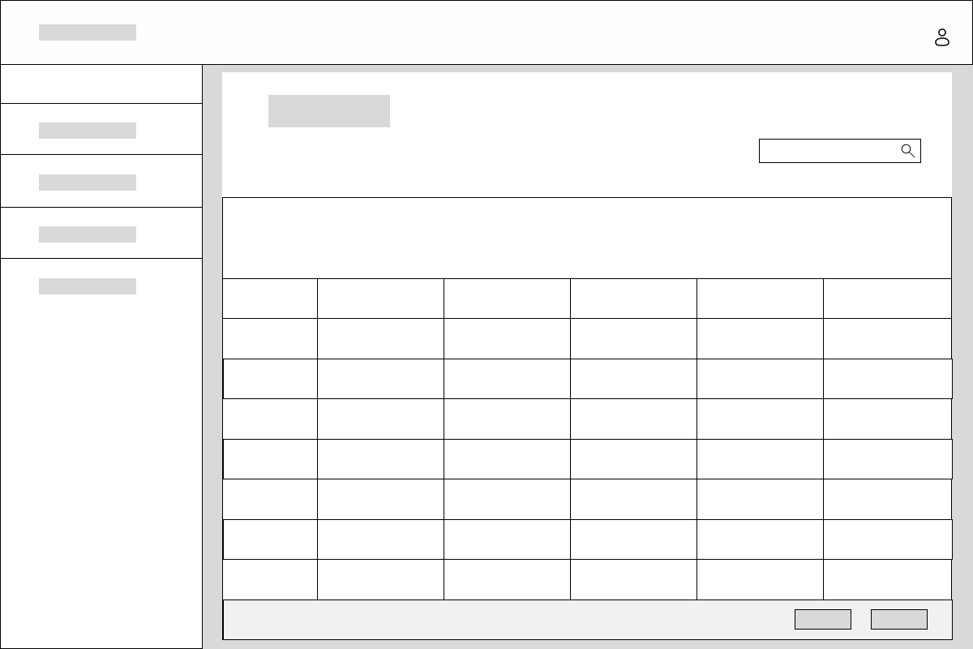

*Figure 18 wireframe of parking owner and admin displaying all the booking list*

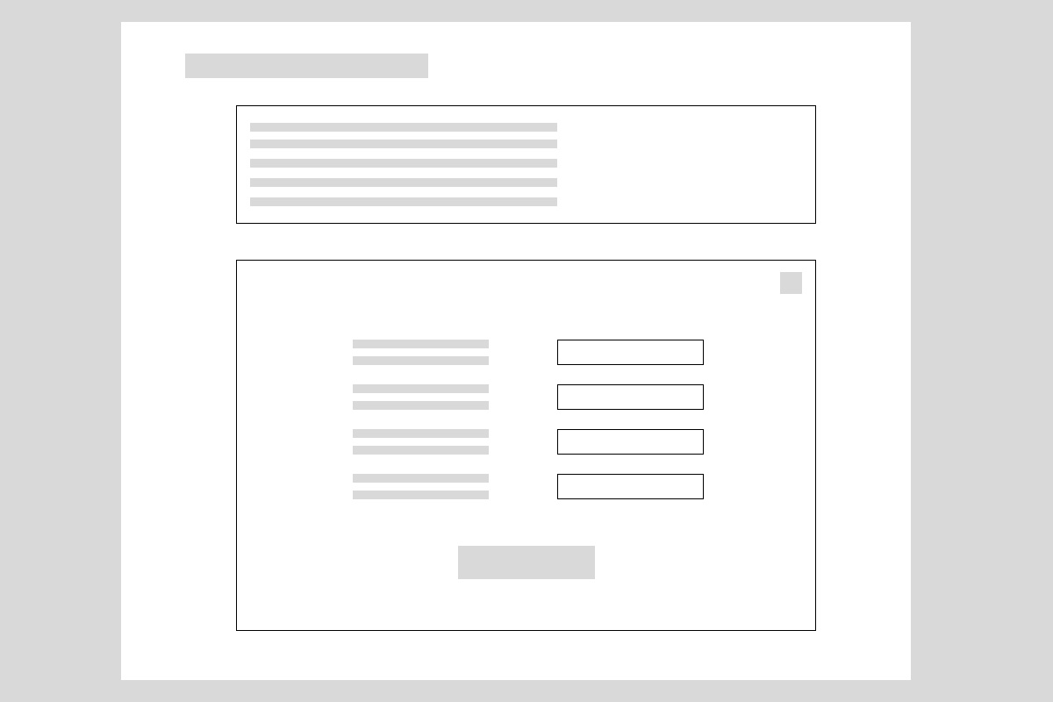

*Figure 19 wireframe of user adding vehicle information*

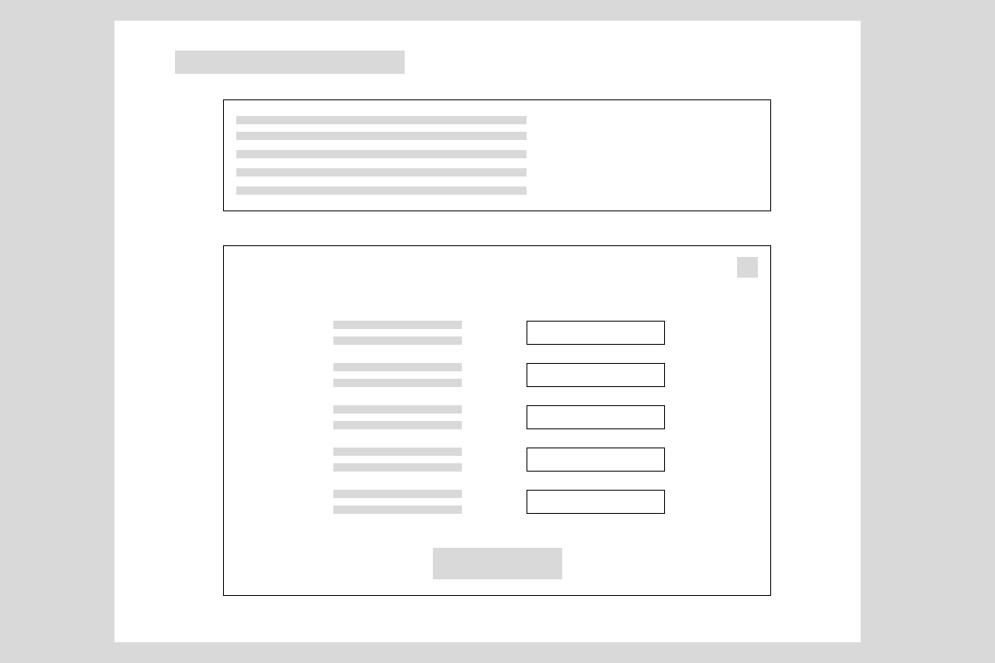

*Figure 20 wireframe of parking owner and admin adding violation by a vehicle form*



*Figure 21 wireframe of parking owner and admin adding parking space details*



*Figure 22 wireframe of admin adding parking owner form*



*Figure 23 wireframe of user booking parking space*

### **Mock-up Screen**

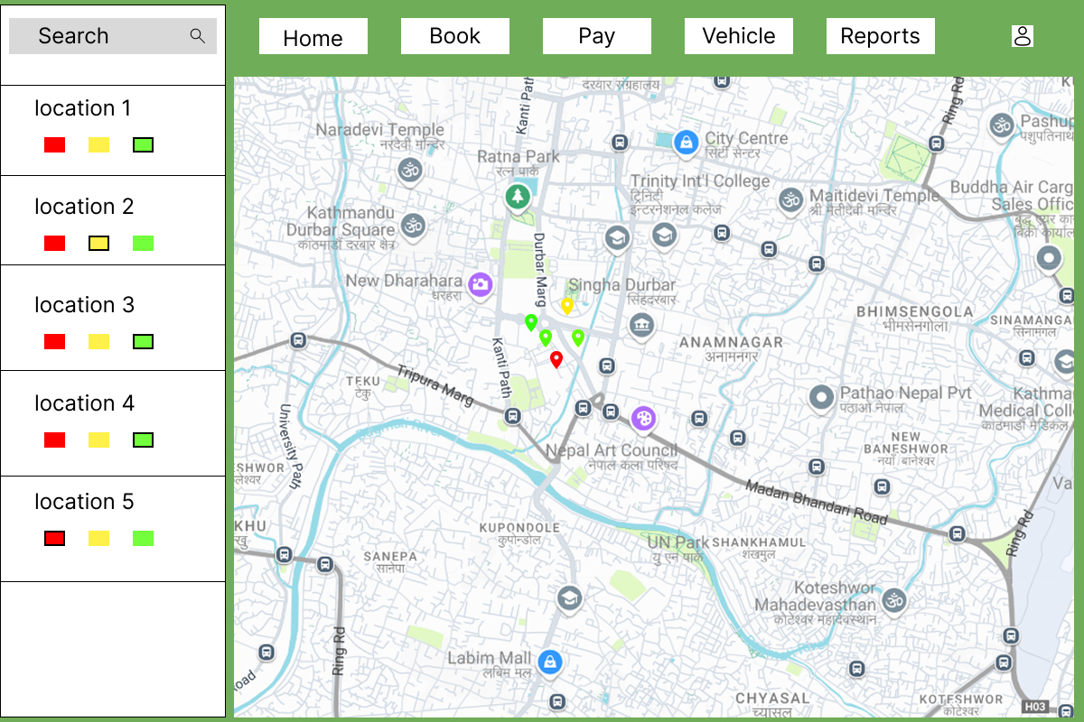

*Figure 24 Mock-up screen of user searching for parking location*

### **Use Case diagram**

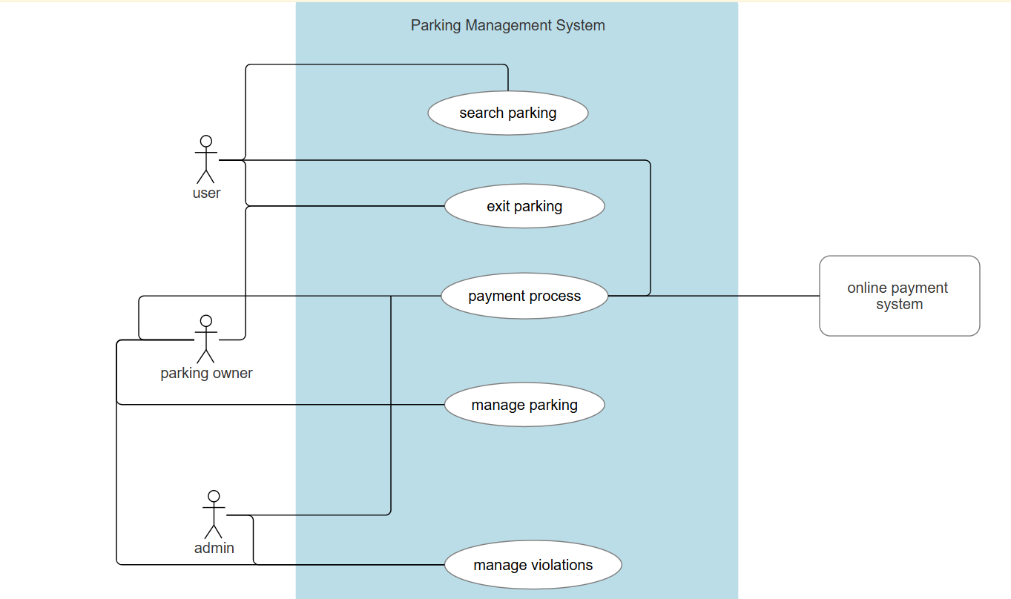

*Figure 25 use case diagram of parking management system*

### **Sequence diagram**

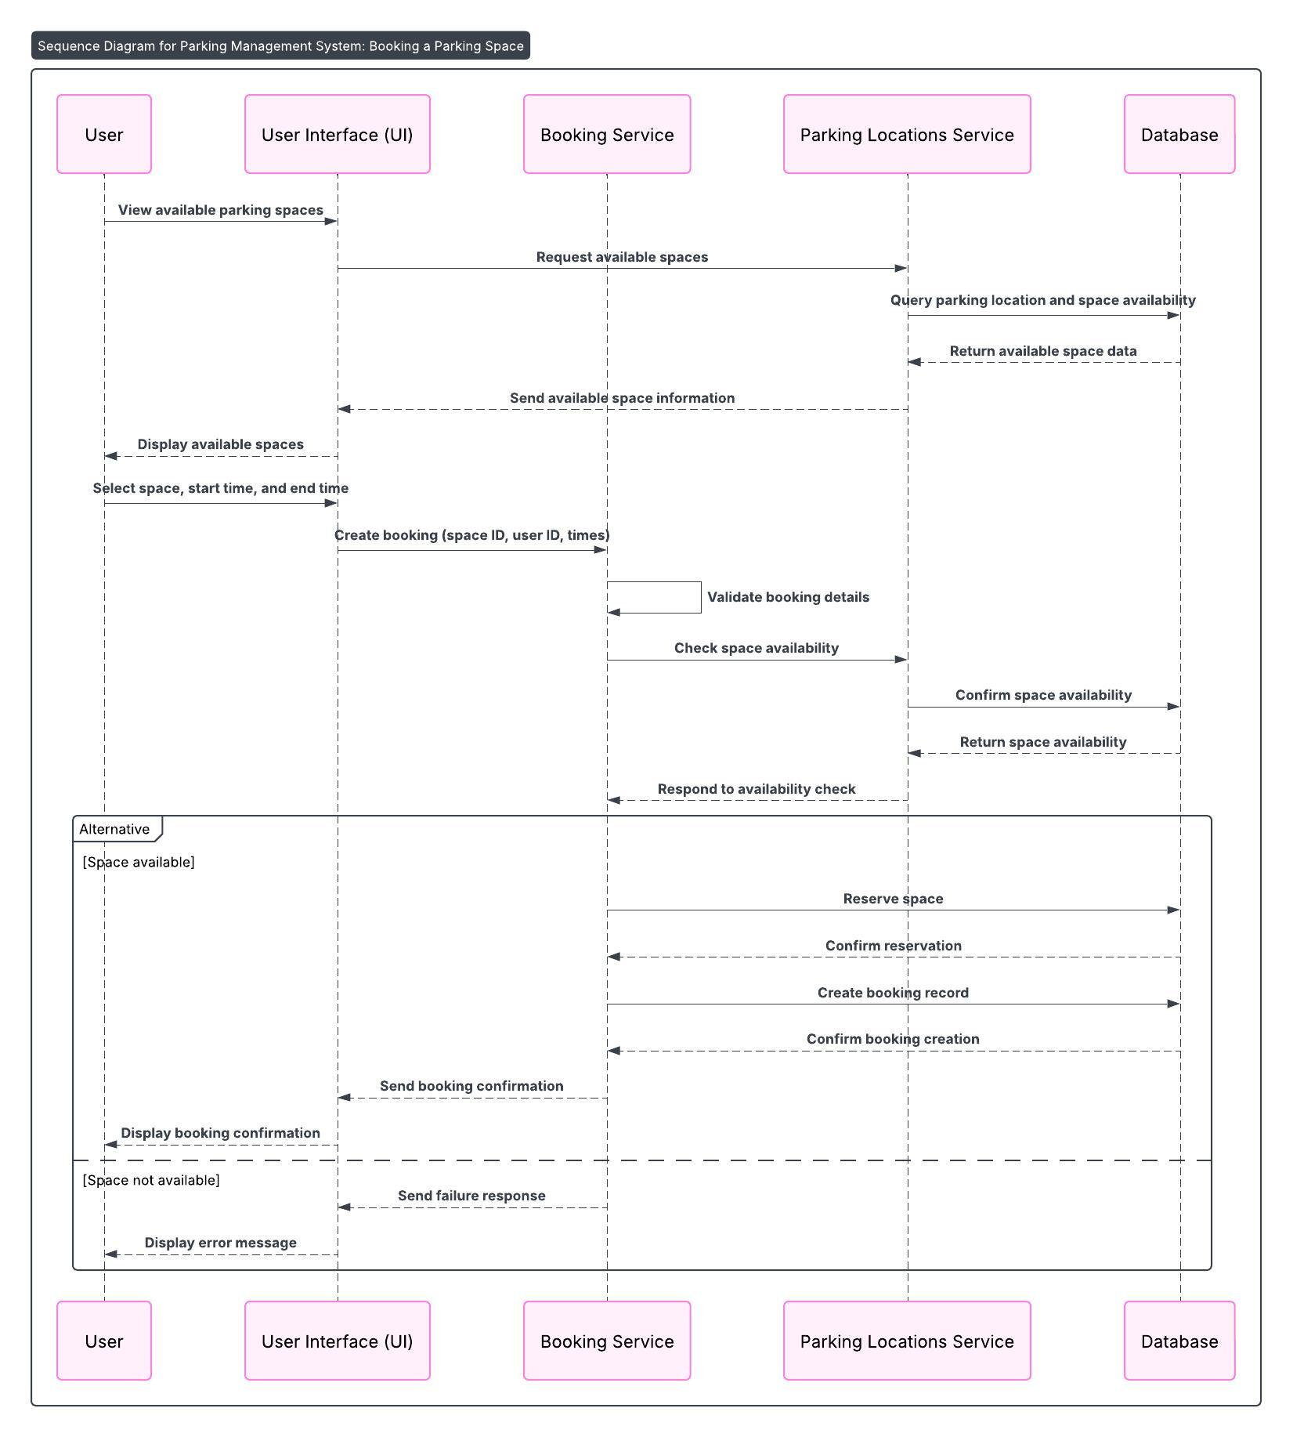

*Figure 26 Sequence diagram of user booking a parking space*

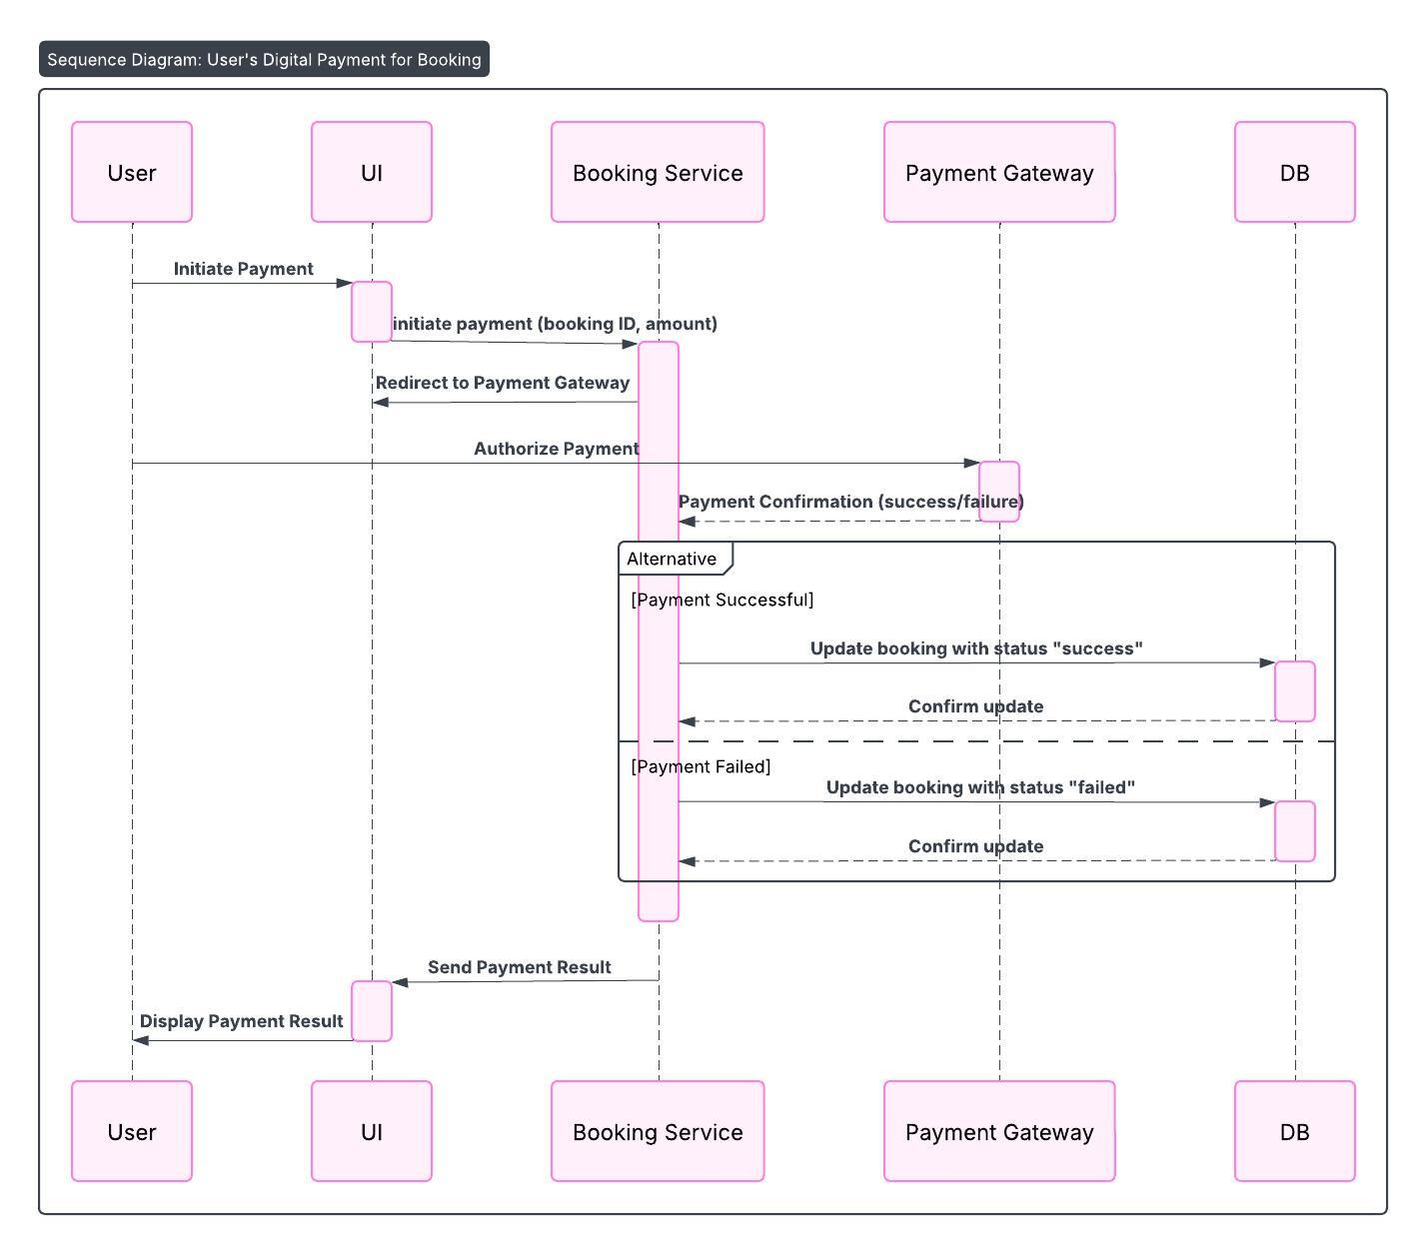

*Figure 27 Sequence diagram of user digital payment for booking*

# SYSTEM BUILD NOTES

*Figure 28 code connecting to database*

# Testing strategy

## Synopsis of Testing

The system will be tested through unit testing, integration testing, and user testing.

Unit Testing:

* Code Coverage
* Test Case Pass Rate
* Defect Detection Rate

Integration Testing:

* Interface Coverage
* Test Case Pass Rate
* Defect Detection Rate

User Testing:

* Task Success Rate
* Time on Task
* User Satisfaction
* Error Rate

## Test results

# SYsteM Evaluation

## Usability Evaluation

## Project Conclusions

# References

Ashish Dhoke, P. S., 2024. *Exploring the complexities of GPS navigation: addressing challenges and solutions in the functionality of gogle maps,* Pune, India: IEEE.

Ashwini Sunil Chaure, R. S. M. M. S. M. S. B. V. S. B., 2024. *Enhancing navigation systems: a comprehensive survey with proposed innovations for improved user experience,* Pune, India: IEEE.

Li Lyu, N. F., 2023. *Research and designof intelligent parking management system based on UML technology,* Dalian, China: IEEE.

Lolwa Hassan Alnuaimi, J. A. J., 2024. *Preventing Fraud in E-tickets validation using the 2FA approach,* Cairo, Egypt: IEEE.

Parkopedia, 2025. *Parkopedia.* [Online]   
Available at: https://www.parkopedia.com/  
[Accessed 20 april 2025].

parkWhiz, 2025. *parkWhiz.* [Online]   
Available at: https://www.parkwhiz.com/  
[Accessed 26 april 2025].

SportHero, 2025. *SpotHero.* [Online]   
Available at: https://spothero.com/  
[Accessed 25 arpil 2025].

Store, G. p., 2025. *Google play store- eparking.* [Online]   
Available at: https://play.google.com/store/apps/details?id=fi.igl.eparking&hl=en  
[Accessed 25 april 2025].

Y. Tanvi, B. L. S. P. B. N. S. M. R., 2024. *A hybrid travel and parking ticket pass for the united arab emirates transport services,* Kamand, India: IEEE.

# Appendix 1: GANTT CHARTS

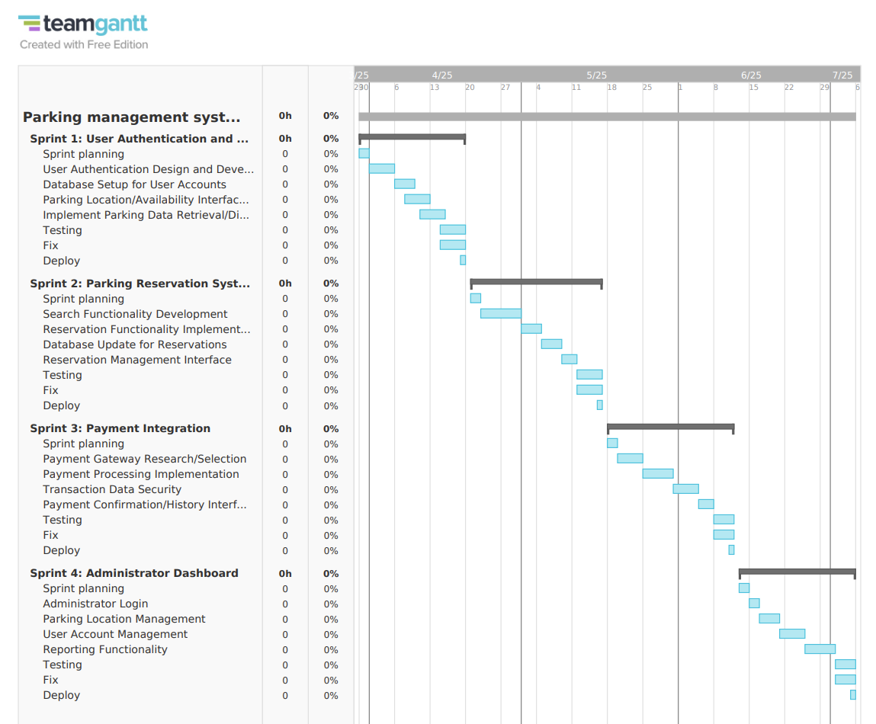

*Figure 29 previous estimated timeline*

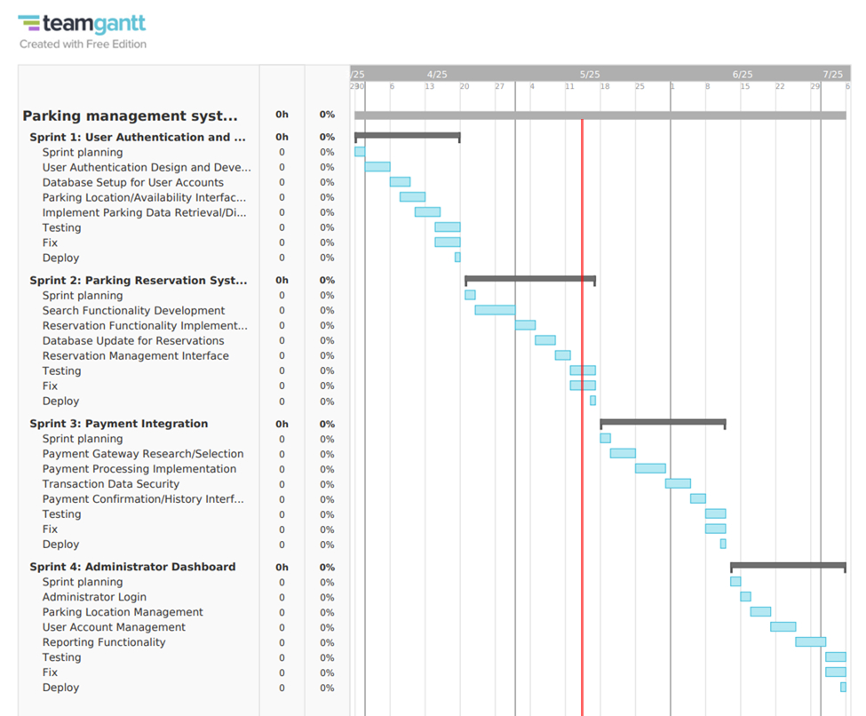

*Figure 30 current timeline indicated by red line*

# Appendix 2: SUPER VISOR LOG

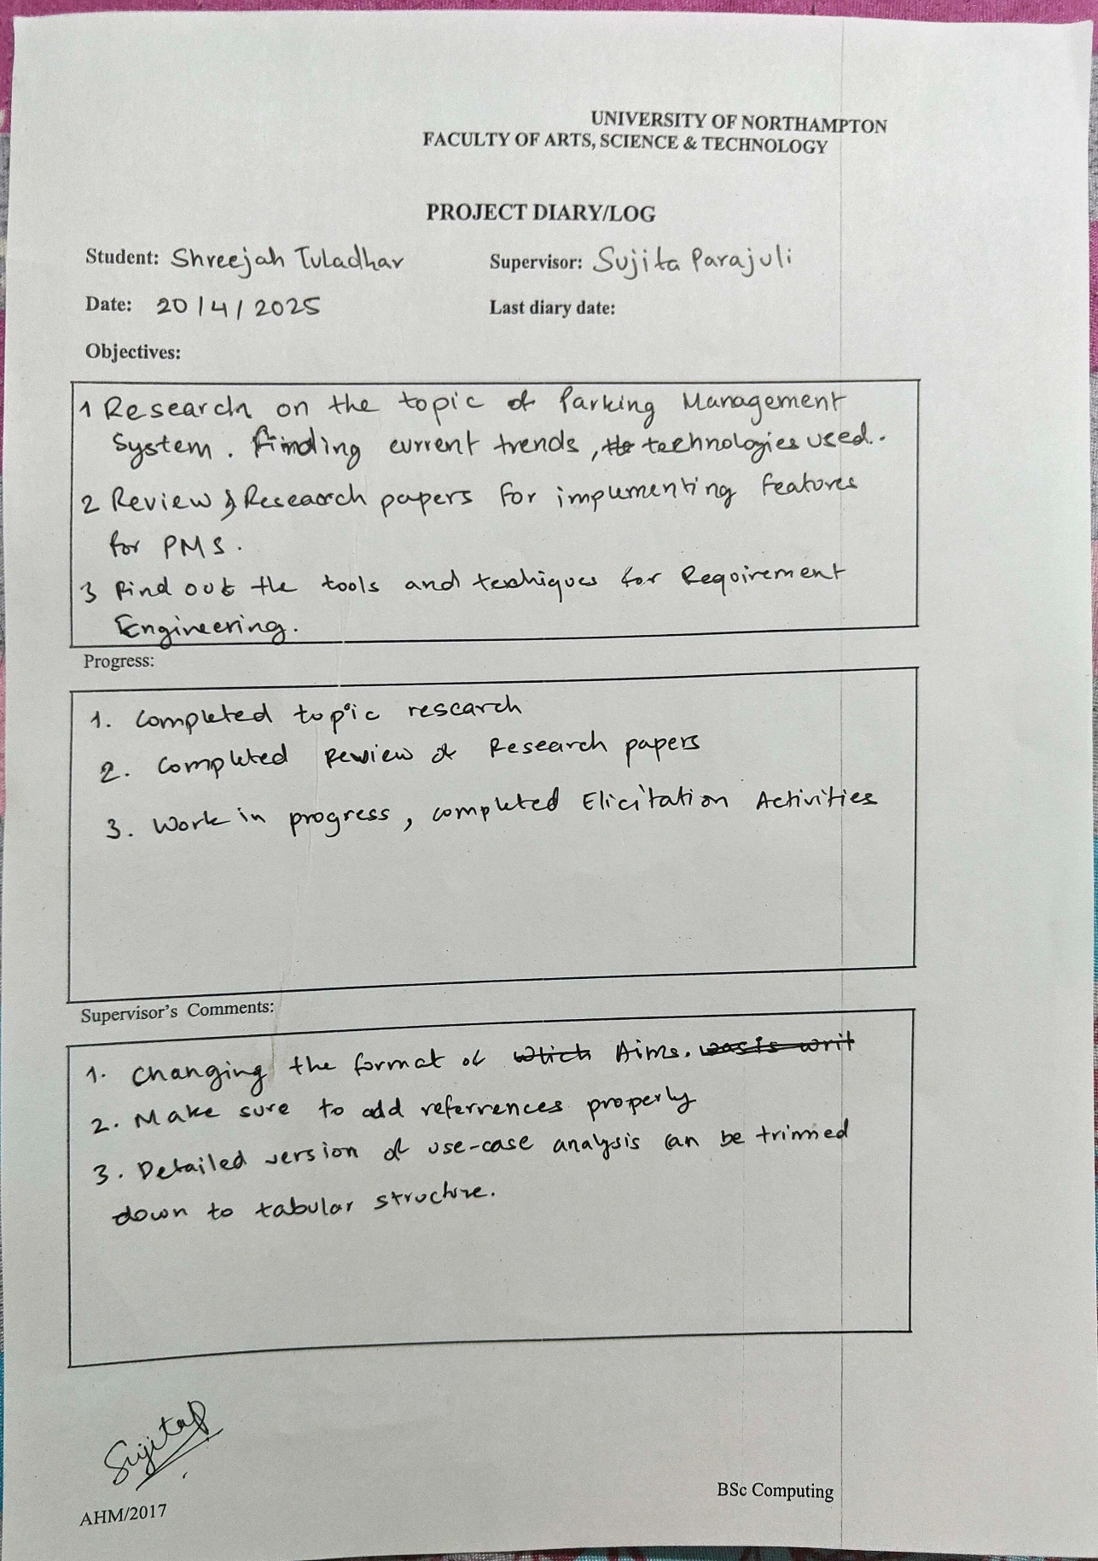

*Figure 31 supervisor log 1*

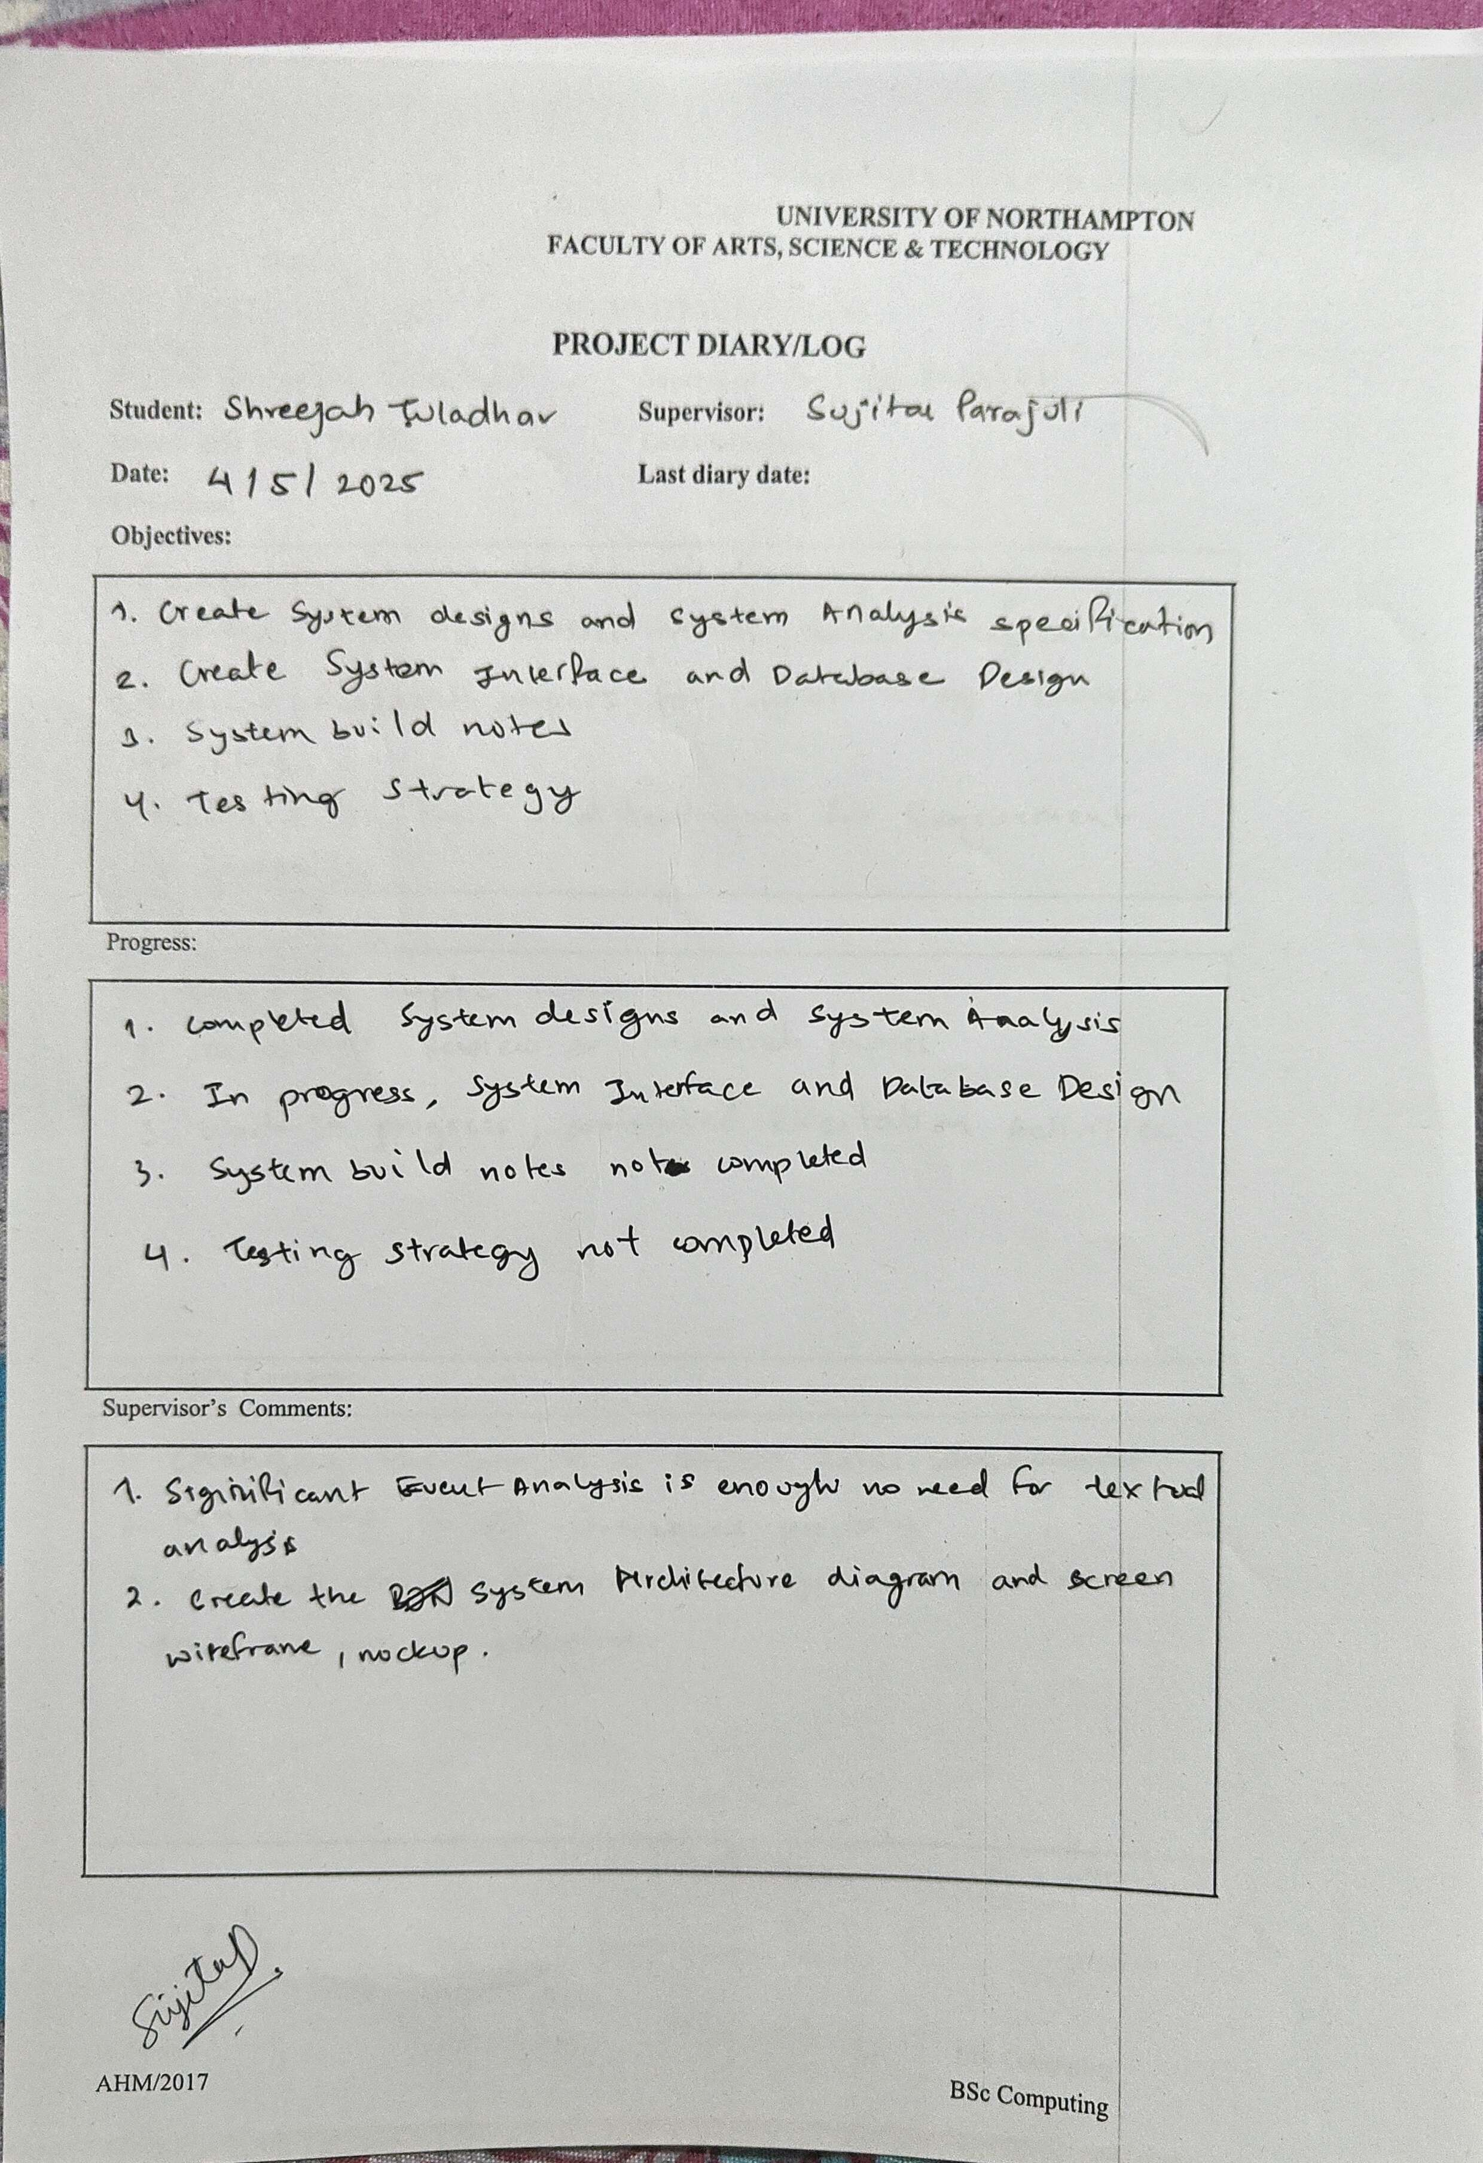

*Figure 32 supervisor log 2*